**Exercise 1: Control Structures**

**Scenario 1:** The bank wants to apply a discount to loan interest rates for customers above 60 years old.

* + **Question:** Write a PL/SQL block that loops through all customers, checks their age, and if they are above 60, apply a 1% discount to their current loan interest rates.

**Scenario 2:** A customer can be promoted to VIP status based on their balance.

* + **Question:** Write a PL/SQL block that iterates through all customers and sets a flag IsVIP to TRUE for those with a balance over $10,000.

**Scenario 3:** The bank wants to send reminders to customers whose loans are due within the next 30 days.

* + **Question:** Write a PL/SQL block that fetches all loans due in the next 30 days and prints a reminder message for each customer.

**Code:**

**Scenario 1:**

BEGIN

FOR cust IN (

SELECT c.customer_id, l.loan_id

FROM customers c

JOIN loans l ON c.customer_id = l.customer_id

WHERE c.age > 60

)

LOOP

UPDATE loans

SET interest_rate = interest_rate - 1

WHERE loan_id = cust.loan_id;

DBMS_OUTPUT.PUT_LINE('1% Interest discount applied to Customer ID: ' || cust.customer_id);

END LOOP;

END;

**Output:**

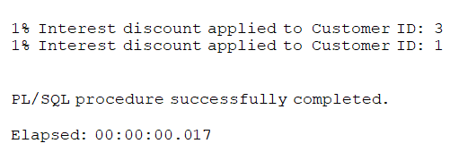

**Scenario 2:**

BEGIN

FOR cust IN (SELECT customer_id, balance FROM customers) LOOP

IF cust.balance > 10000 THEN

UPDATE customers

SET isVIP = 'Y'

WHERE customer_id = cust.customer_id;

DBMS_OUTPUT.PUT_LINE('Customer promoted to VIP: ' || cust.customer_id);

END IF;

END LOOP;

END;

**Output:**

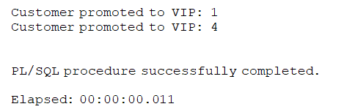

**Scenario 3:**

BEGIN

FOR due_loan IN (

SELECT l.loan_id, c.name, l.due_date

FROM loans l

JOIN customers c ON l.customer_id = c.customer_id

WHERE l.due_date BETWEEN SYSDATE AND SYSDATE + 30

) LOOP

DBMS_OUTPUT.PUT_LINE('Reminder: Loan ID ' || due_loan.loan_id ||

' for customer ' || due_loan.name ||

' is due on ' || TO_CHAR(due_loan.due_date, 'DD-MON-YYYY'));

END LOOP;

END;

**Output:**

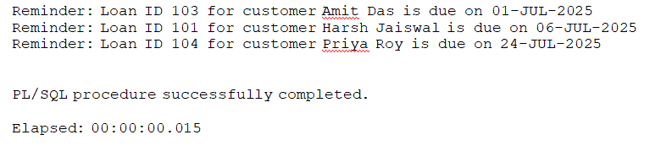

**Tables:**

CREATE TABLE customers (

customer_id NUMBER PRIMARY KEY,

name VARCHAR2(100),

age NUMBER(3),

balance NUMBER(10, 2),

isVIP CHAR(1) DEFAULT 'N' -- 'Y' or 'N'

);

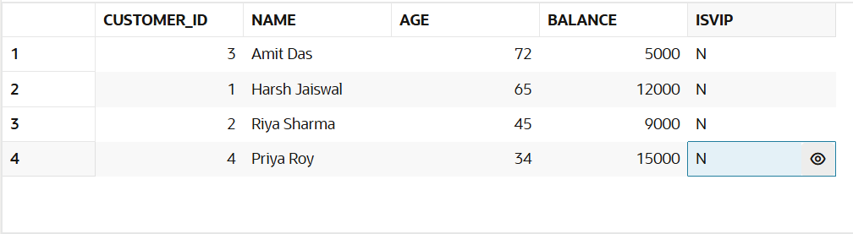

CREATE TABLE loans (

loan_id NUMBER PRIMARY KEY,

customer_id NUMBER,

interest_rate NUMBER(5,2),

due_date DATE,

CONSTRAINT fk_customer FOREIGN KEY (customer_id) REFERENCES customers(customer_id)

);

